Iteration One: Testing Screenshots

# 1.12.1

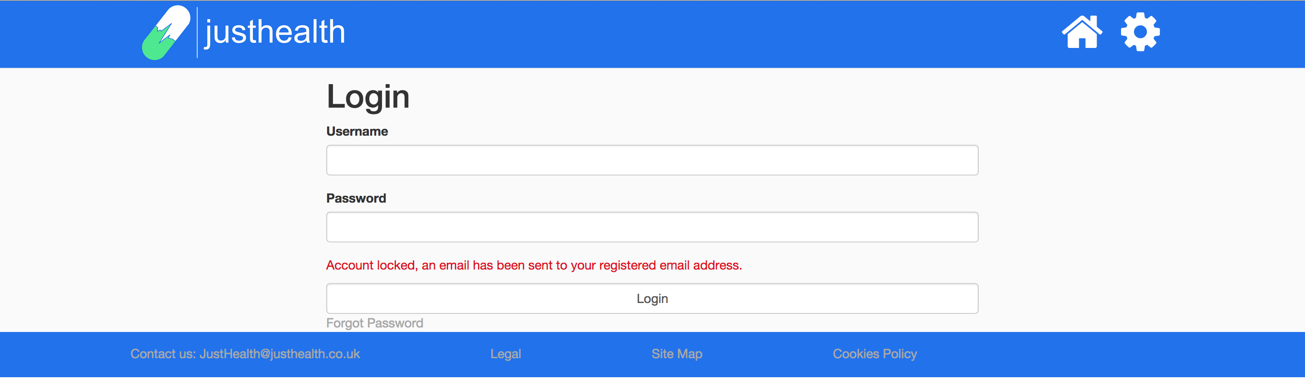

# 1.12.2.



# 1.12.7

